 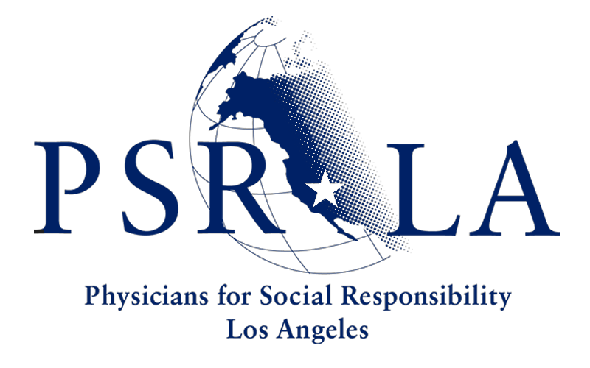 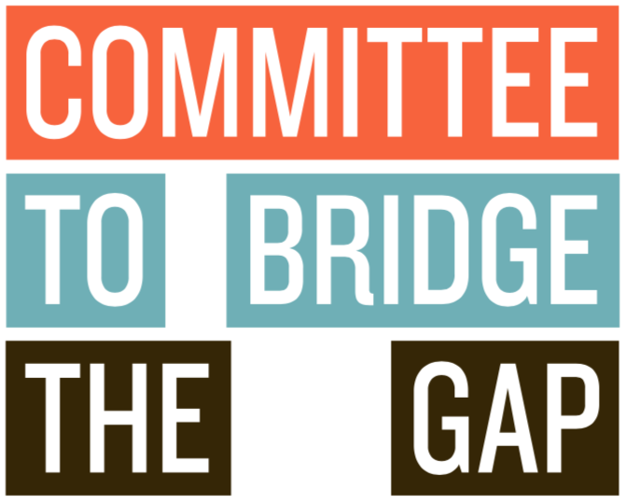

August 21, 2020

Peter Zorba

Project Director

Santa Susana Field Laboratory

5800 Woolsey Canyon Road

Canoga Park, CA 91304

by email to: [msfc-ssfl-eis@mail.nasa.gov](mailto:msfc-ssfl-eis@mail.nasa.gov), [peter.d.zorba@nasa.gov](mailto:peter.d.zorba@nasa.gov)

Re: Comments on Final Supplemental Environmental Impact Statement for Soil Cleanup Activities at Santa Susana Field Laboratory

Dear Mr. Zorba:

The National Aeronautics and Space Administration (NASA) has recently issued a Final Supplemental Environmental Impact Statement (FSEIS) for remediation of its portions of the Santa Susana Field Laboratory (SSFL). The preferred alternatives put forward in the FSEIS would violate the Administrative Order on Consent (AOC) that NASA executed with the California Department of Toxic Substances Control (DTSC) in 2010; the Resource Conservation and Recovery Act (RCRA), 42 U.S.C. §6901 *et seq;* and other legal requirements, as well as commitments made by NASA. The FSEIS itself also is at variance with the National Environmental Policy Act (NEPA), 42 U.S.C. §4321, *et seq*.

As we indicated in our comments on the Draft SEIS, the choice of how much of the pollution that NASA created will be cleaned up is beyond NASA’s discretion and outside its authority. The AOC requires a cleanup to background, and even if the AOC did not exist, the remediation decision under RCRA rests with NASA’s regulator, DTSC, not NASA.

In the FSEIS, NASA has identified as its agency-preferred alternative, Alternative C, which would, by NASA’s own admission, violate the 2010 AOC to which it is legally bound and would leave approximately 72% of the contaminated soil not cleaned up by volume. See FSEIS p. 2-13. Its other “environmentally preferred alternative,” Alternative D, would likewise violate the AOC and would leave 80% of the contaminated soil volume not remediated. *ibid.* NASA’s preferred alternatives would leave 84% and 88% of its contaminated acreage not cleaned up, respectively. *ibid.*

The dramatic nature of NASA’s proposed breach of its AOC commitments and the sizable amount of contaminated soil its “preferred alternative” would leave not cleaned up can be seen in two of NASA’s own maps in the SEIS. The first shows how much contaminated soil NASA admits to being responsible for cleaning up in its parts of SSFL under the agreement it signed in 2010:

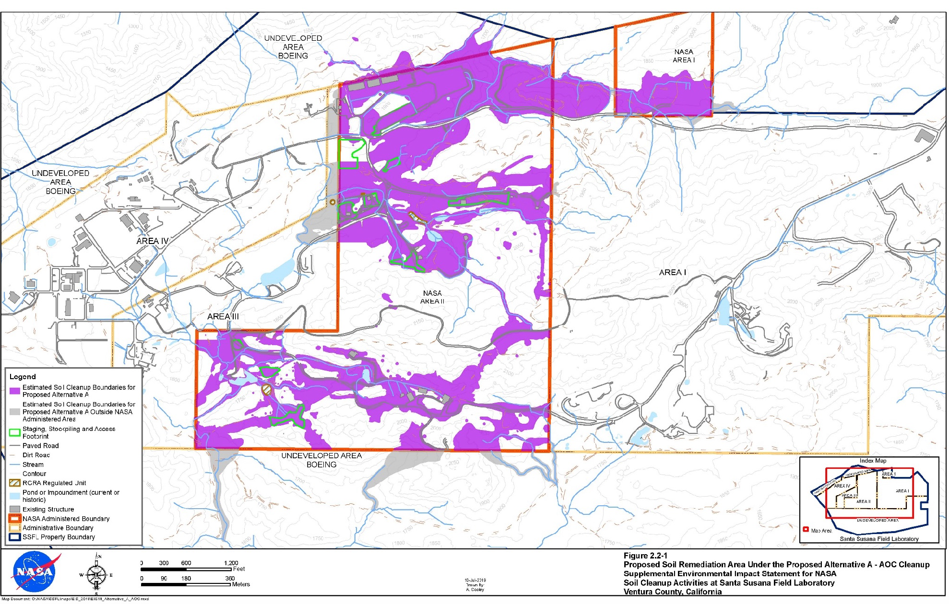

The second map shows how little of that contamination it now proposes to clean up, leaving the rest unremediated and available for continued migration and exposure to the public:

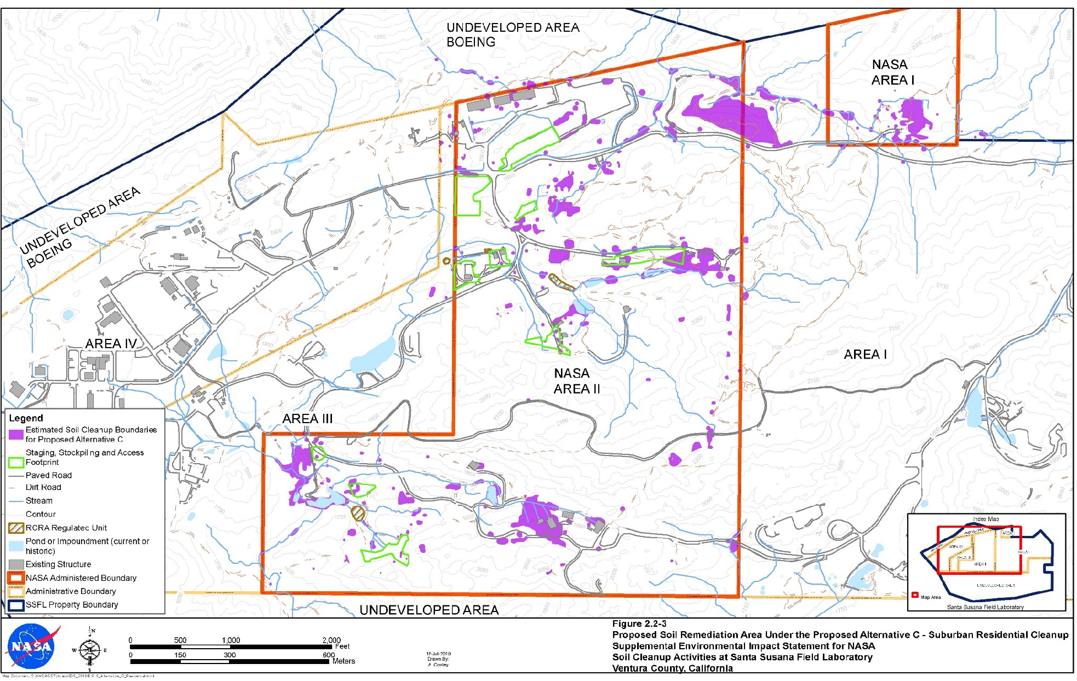

As we warned in our comments on the DSEIS, NASA’s action is unlawful in terms of process and substance. If the agency were to follow the preferred alternatives in the FSEIS, Californians would be harmed and meaningful cleanup would be foreclosed for future generations. The decision by the Trump Administration NASA to issue this FSEIS sets the stage for abandoning huge amounts of chemically hazardous material and would consign this important land in Southern California, set in the midst of millions of California residents, to never be cleaned up. Collectively, as we did in our comments on the DSEIS, the undersigned Natural Resources Defense Council, Committee to Bridge the Gap, and Physicians for Social Responsibility-Los Angeles urge NASA to withdraw the FSEIS, issue no Record of Decision based thereon, and instead immediately commence working to quickly reach compliance with the AOC that the agency signed nearly a decade ago.

Failure to Address in the FSEIS the Vast Majority of Specific Comments on the DSEIS

Among the core elements of NEPA is the requirement to consider and respond to all substantive comments. NASA fails in the FSEIS to respond to the great majority of specific comments we and others made during the comment period on the DSEIS. Our comments alone consisted of sixty pages of detailed points and more than thirty exhibits. NASA simply ignores virtually all of the issues raised.

Shielding from Public Scrutiny and Comment the Most Fundamental Portions of the SEIS

We also object to the fact that the arguably most substantive matters for the SEIS, the choice of preferred alternatives, and the analysis and methodology for making that choice, were not included in the draft SEIS, and thus were shielded from the opportunity for public review and comment that lies at the heart of NEPA. [FSEIS, Appendix 2G Environmentally Preferred Alternative Calculation, and the deeply flawed methodology upon which the preferred alternative selection is based (FSEIS p. 2-26 - 28.)**]** The FSEIS sections identifying the preferred alternatives and the methodology employed for choosing them were not included in the Draft SEIS, nor was Appendix 2G. Thus, the course set and chosen by the agency was not presented until this document, done after the official public comment period. Such an omission on NASA’s part is counter to its fundamental NEPA obligations for a full, comprehensive review that can inform the decisionmaker.

Another problem is the haphazard and misleading nature of the agency response to comments. Specifically, the FSEIS Appendix 2G includes a matrix which ranks the impacts of each cleanup alternative according to a weighting purportedly based on the number of members of the public who had made comments concerning that category of impact. For example, health and safety was given a ranking of 4, while cultural, biological, and transportation were each given a ranking of 3, water and air quality were each given a ranking of 2, and geology, noise, and hazardous and nonhazardous waste each given a ranking of 1.

This weighting is inaccurate. The *actual* number of public commenters on the DSEIS who raised concerns about health and safety was approximately 961, while only 10, 8, and 9, did so for cultural, biological, and transportation matters respectively. Thus, even were one to accept NASA’s purported methodology of weighting impacts by the number of public comments concerning them, the weighting factor for health and safety should be on the order of 100 times higher than NASA says. For example, if the weighting NASA has given for biological, cultural, and transportation is 3 each, then health and safety should be given a weight of about 300, not 4. The NASA weighting for health and safety is thus low by two orders of magnitude, given its own stated methodology. (The comments that came in on the Draft EIS show a similar heavy weighting of comments about health and safety compared to the other issues.)

Second, the very establishment of a single health and safety impact category while including as separate categories numerous non-health ones immediately skewed the calculation by a factor of 8 to 1. Even with the (erroneous) weighting values given by NASA, health and safety concerns would automatically be overwhelmed by all the other categories four-fold, 16 to 4. NASA’s weighting further biases the preferred alternative against protecting health and in favor of NASA’s apparent goal of dispensing with meeting its cleanup obligations.

Additionally, in this new Appendix 2G, NASA makes the extraordinary assertion that there is absolutely no difference between the cleanup alternatives in terms of protecting public health and safety. When determining the impact that the four cleanup alternatives would have on health and safety, NASA assigns the same impact score to all four cleanup alternatives. Leaving none of the contamination behind and leaving 90% of the contamination not cleaned up has precisely the same quantitative positive impact on public health, NASA claims. NASA admits that cleaning up the contamination has a significant, beneficial impact, but without any basis asserts that one-tenth the cleanup has precisely the same benefit as a full cleanup.

Put differently, NASA asserts that the public health risk from leaving behind concentrations of Aroclor 106 (a PCB) of 3800 micrograms/kilogram, to just take the first toxin listed in Appendices 2A and 2C, is identical to the risk from leaving behind only concentrations of 17 micrograms/kilogram, the AOC cleanup level. Risk, particularly for carcinogens, is generally proportional to concentration. The risk from more than one hundred times the AOC concentration cannot be equal to the risk at the lower concentration.

Furthermore, NASA has removed from consideration the time period of the impacts. Whereas negative impacts (e.g., transportation or noise associated with any cleanup activities) are temporary, health and safety benefits of remediating the contamination are permanent. This further biases the preferred alternatives analysis.

All together, each of these assumptions results in biasing the calculation of preferred alternatives. It creates the appearance that NASA was reverse-engineering a predetermined outcome to support a position whereby it could break the cleanup agreement – specifically, abandoning most of the contamination in place, and coming up with assumptions that support that desired conclusion.

Conclusion

NASA signed a legally-binding agreement in 2010 to clean up by 2017 all its contamination at SSFL, with narrow exceptions. We are in 2020 and the promised soil cleanup has not even begun. Now NASA has issued a Final SEIS proclaiming its preference is to instead leave the great majority of the contaminated soil and contaminated acreage not cleaned up, in direct violation of the AOC. NASA does not have the discretion to take such action. And were the agency to attempt to do so in violation of law, public health and safety would be at risk. NASA should live up to its cleanup commitments, follow the law, rescind the FSEIS, and finally stop dragging its feet on compliance with remediating the toxic pollution its decades of inadequate environmental controls created.